Introduction: Coming to Quiet
So often when we gather as a staff community, a leadership team, a group of colleagues, our focus is on the children and young adults in our care. The agenda before us may shape the community we are creating together, and the educational experiences that engage the students in their learning. For this we need to be really present. Each person’s wisdom and experience can contribute to shaping the future. A quiet focussed introduction to a staff meeting can be an invitation to be really present to each other and to the agenda. Such presence can lead to a fruitful meeting.
The reflections that follow are to invite such attentive presence. Let this poem invite us to enter into the silence for others, those students who are entrusted to our care, and our colleagues with whom we share this responsibility.

THE EMBRACE OF SILENCE
The silence gathers us
and we are one

There comes the time
the waking of our awareness
when we enter into the silence for others
for those so traumatised, tortured, desperate
depressed, lonely, spent…
there seems no way.

We enter into the silence
and take them with us
wherever they be
hold them tenderly there
resting in her arms
knowing what silence and touch
mean to us
the healing they have wrought
the life they have opened out
the grace they gift
we desire earnestly for all.

When we enter into the silence for others
the silence takes us to her heart
and into the awareness of Francis and Clare
that all of life is sister, brother, lover.
Noel Davis
– The Heart Waking

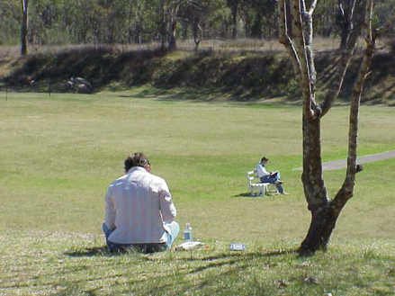
May the reflections encourage you to enter silence, a silence that speaks, reveals….

