Introduction - Teaching as Vocation and Ministry
Parents and teachers engage in profound work. Parents gift the community with the next generation, and in partnership with teachers nurture them to become people of wisdom and integrity. No work is more profound than that.

For teachers in Catholic schools the gospel is the ground of our being. Through pondering the life and teaching of Jesus we gain insight into what the promise of the gospel – fullness of life – looks like, and how to invite each other to journey into that fullness. Jesus was a lay person. He had no position of power or responsibility in the Jewish faith or the Roman ruling class. Yet two thousand years later his wisdom and his spirit continue to shape the lives of so many. He liked to be called ‘teacher’. And he truly was that.

What did he teach? The essence of his teaching was love: love one another as I have loved you, and love your neighbour as yourself. His life and teaching are all about love; showing us what it looks like; pointing out where it was missing.

How did he teach? He told stories that connected people with some of the daily routines and trades of his day. The sower – people were food producers; they made containers out of animal skins: don’t put new wine in old skins; The good Samaritan: an ‘outsider’ was more compassionate than the priest and the Levite – the holy ones.

Where did he teach? He taught everywhere. His life was a lesson. The way he encountered people; being a companion on a journey; engaging in conversation at table; in the public gathering places; in the temple courtyard…..

Another question to ask: Where did Jesus learn? No doubt his first teachers were his parents. With them he learnt to walk, to speak, to pray, to play, to relate, maybe even a trade.

But where did the deep wisdom come from? Throughout the gospels we are often told that long before dawn Jesus went to a lonely place to pray; to be in communion with his Abba. So throughout his public life we see this rhythm of solitude and engagement. During those times of solitude was he bringing the experiences of his daily encounters into dialogue with Abba; endeavouring to discern those elements of the culture which were not life giving for the people? Is that where he found the courage to question the religious leaders? A questioning that resulted in death.

As teachers we are engaged in the same work but in a different cultural context. We too need a rhythm of solitude and engagement if we are to provide an education that enables those entrusted to us to grow in wisdom and integrity. In our classrooms are the future parents, leaders, business people, artists, academics, etc. If we are to educate well, we too, like Jesus need that rhythm of solitude and engagement. Solitude to remain in touch with the Spirit whispering in the depths of our being; engagement as disciple, to enable God’s mission to be carried out today.

The following reflections are an invitation to ponder our work as teachers. We have so much to learn from each other, but often we need to be called together in a safe interpersonal space for this to happen. May the following reflections provide an opportunity to engage in personal reflection, conversation and dialogue about the work we have committed our lives to: educating the young.
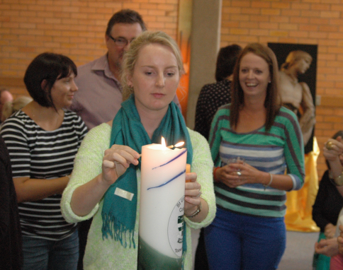
Let Christa McAuliffe have the final words:
‘I Touch the Future – I Teach.’

Before engaging in the reflections it might be helpful to ponder and engage in conversation around some of the ideas Gloria Durka explores in her book: The Teacher’s Calling – A spirituality for those who teach.
A sense of our calling keeps us on course. If we believe, in the depths of our souls, that what we do in the classroom makes a difference in the lives of these we teach, we can live and work in a different world from that which meets the eye. We can inhabit a world in which we see youngsters with many strikes against them who have a great deal to learn about life and about getting along with others. This is the world in which we must believe and act if our efforts as teachers are significant and worthwhile. This conviction can enable us to work patiently and persistently with youngsters whom many other teachers may find unbearable. Our way of life embodies the belief that improvement of self and of human life are always worth whatever it takes to create a better world for all…..this belief lies at the heart of what being a teacher is all about.
Page 9

We may teach for years before we genuinely begin to feel it as a vocation and treat it as such. It takes a while for us to realise just how much our work embodies our vision of teaching and our beliefs about our students. We grow to understand that teaching is a calling that makes claims on our souls.
Page 3

When did you first know you wanted to be a teacher? Was it a decision you came to quickly, or did it emerge gradually over time? Perhaps you are still wondering why you are teaching? Such questions are not easily answered, and they usually are pondered for years. They are not simply questions about our job, though they include job-related issues: These are questions about our soul’s life and work. For this reason, teaching cannot be treated as a routine job --it flows from an inner incentive. Teaching is more a vocation than a job.
Page 3

Each teacher’s vocation is unique. Even though there are common threads in the calling of each teacher, each teacher dwells in the role in a unique way. We each give our vocation a distinctive personal stamp. The individual who occupies the role of teacher makes all the difference. If we can see ourselves as non-inter-changeable with others, we can enrich what we do with more significance.
We are more like architects than labourers, more like artists than mechanics.
We not only strive to gain skills necessary to do our work but we strive to know better those for whom we work. Our work is a common work that each of us does in our own unique way.
Page 6.

The sense that one has something to contribute, that one can make a difference, and that one can shape the world and not just be shaped by it... that shows the power of a sense of vocation. Finding success with some of our students attests to the practical value of our desire to serve. We would do well to find ways to celebrate these moments with one another. Such a sense of vocation is not a set of glasses or lenses that we can take off and put on at will. It is not an arbitrary way of looking at life. Such a way of looking at life is a result of our character that has been formed over time. It flows from our soul.
Page 11

Schools can be places where teachers come together to live out their vocation, not only places to engage in activities in order to satisfy accrediting agencies. I believe it is possible for schools to be forums of learning that are shaped to help teachers view their work as participation in the formation of another’s story and to have their own story influenced by the other. Such a vocation is to answer the call of community and tradition. The community includes the youth, adults and families served by the school. The traditions are the communal recollections and hope that give structure, meaning and value to individual and collective life.
Page 63

